



MATH

CHALLENGE TOURNAMENT

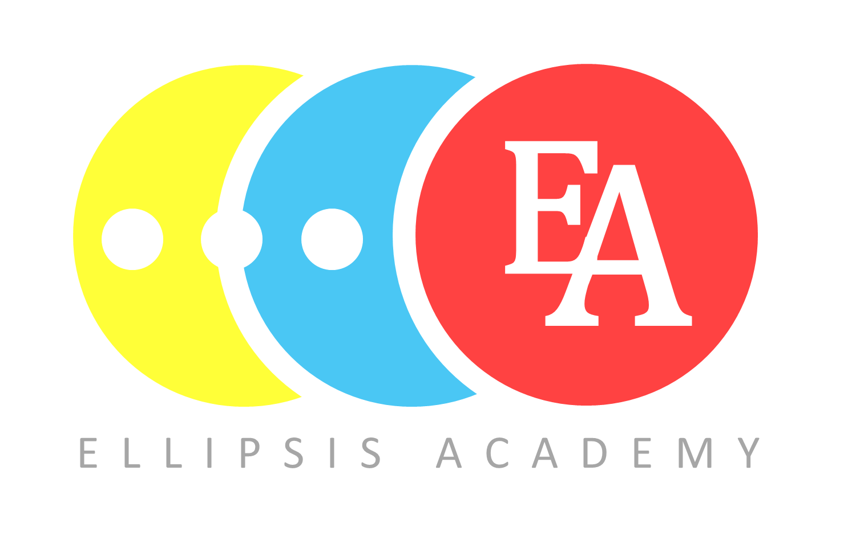

|  |
| --- |
| All registered students will receive a ribbon of participation. Students who are in the top 20 in their grade level and division nationally will earn medals.  Students who score the highest overall in their grade level and division will be awarded with a special prize. |

|  |
| --- |
| When: <date> and <time>  Where: <tournament location> |

REGISTER

[**About the Math Challenge Tournament**](https://www.ellipsisacademy.com/2024-math-challenge-tournament.html)

**GRADE 2 - 5**

*Join us for*

<NORMAN ROCKWELL PTA>

CALLING ALL MATHLETES

Sponsored by our school PTSA.