TOURNAMENT INSTRUCTIONS & GUIDELINES FOR PARTICIPANTS
- Be sure to familiarize yourself with “bubbling” a multiple-choice answer.
- Please bring at least two sharpened pencils and erasers. You may bring a bottle of water. NO CALCULATORS allowed.
- Do not start the competition with an empty stomach. Eat a good meal or have a snack before the tournament starts.
- Please use the restroom before entering the competition room. Once the round starts, if you leave for any reason you CANNOT re-enter the room.
- Please try to remain relaxed before entering the competition room. There will be plenty of time for seat assignments. Do not push other competitors or parents.
- Please familiarize yourself with the format and types of math problems of the Ellipsis Math Challenge Tournament.
- We reserve the right to verify the information submitted by the participants and their guardians. Any evidence of misrepresentation will result in immediate disqualification of the participant, and barring from future competitions.

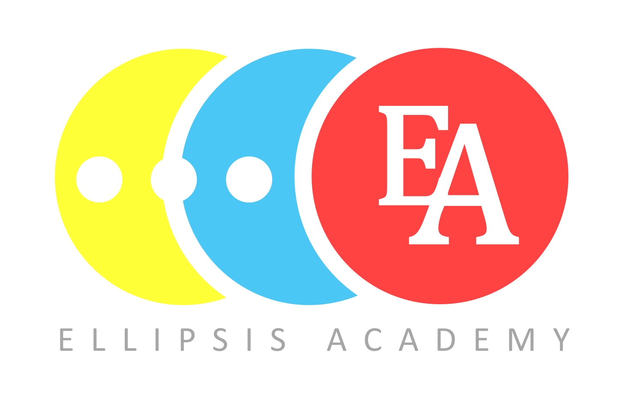
TEST PAPERS WILL NOT BE RELEASED TO PUBLIC UNTIL THE TOURNAMENT WINDOW IS OVER.
FORMAT
2019 problems are in multiple choice format, both on Mental Math Challenge and Problem-Solving Challenge.
Mental Math Challenge (15 minutes) – Students will be presented with 40 problems to be solved by students “mentally”. Because of the emphasis on speed and accuracy, students are given only 15 minutes to answer as many of the 40 problems as they can correctly. Each problem is worth 2 points. Maximum Mental Math score is 80.
Problem Solving Challenge (40 minutes) – Students will be presented with 20 problems to solve. The first 8 questions are worth 5 points, the next 7 questions are of intermediate difficulty and worth 7 points, and the last 5 questions are harder and worth 10 points. During this round, participants will be given scratch paper to do any calculations they need to reach their final answers. Maximum Problem-Solving score is 139 points. The Mental Math and Problem-Solving scores will be added together to determine individual awards for a maximum of 219 points.
​Tournament tests are completed in a traditional way using a paper answer sheet and a pencil.

